Hi,

As discussed yesterday, below is a plot detailing the performance of the F-135 engine’s exit velocity with a changing inlet temperature from the compressor. As inlet temperature rises, the final velocity of the air decreases. The vertical landings must have been taking the outlet gases from the turbine and pulling it through the compressor again at a higher temperature. This greatly reduces its performance.

I suggest finding a solution to this problem by not letting the exit air recycle back into the compressor. If you have any more questions with the results below or any other questions regarding the recycle of the exit air into compressor, don’t hesitate to reach out.

Respectfully,

Charlie Nitschelm

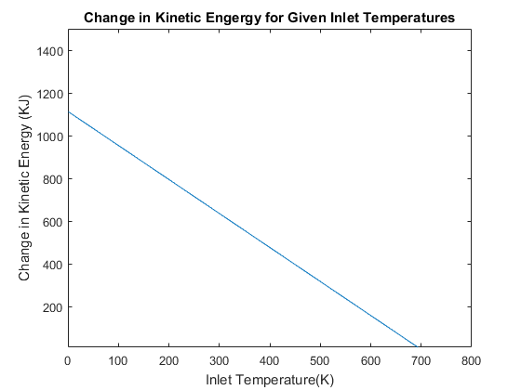

function [ Vfinal ] = performance( T1 )

function [ KE ] = performance( T1 )

% Problem 1 %

P1=100;

R=0.287;

n=1.4;

%Pressure Ratio

r=28;

% State 1 % Compressor

v1 = (R\*T1)/P1;

P2 = r\*P1;

C=(P1\*(v1^n));

v2 = (C/P2)^(1/n);

T2= (P2\*v2)/R;

% State 2 % Combuster

P3 = P2;

T3 = 1540 + 273;

T4 = T3 - (T2-T1);

% State 3 % Turbine

k = (1/0.4);

v3 = (R \* T3)/P3;

v4 = ((P3 \* (v3^n))/(R\*T4))^(k);

P4 = (R \* T4)/v4;

% Nozzle %

P5 = P1;

v5 = ((P4\*(v4^n))/P5)^(1/n);

T5 = (P5\*v5)/R;

% First Law %

KE = (T4-T5);

end

FOR LOOP CODE

vf = zeros(1000);

for i=1:1000

vf(i) = performance(i);

end

x = 1:1000;

plot(x,vf)

ylim([10 1500])

xlim([0 800])

xlabel('Inlet Temperature(K)')

ylabel('Change in Kinetic Energy (KJ)')

title('Change in Kinetic Engergy for Given Inlet Temperatures')